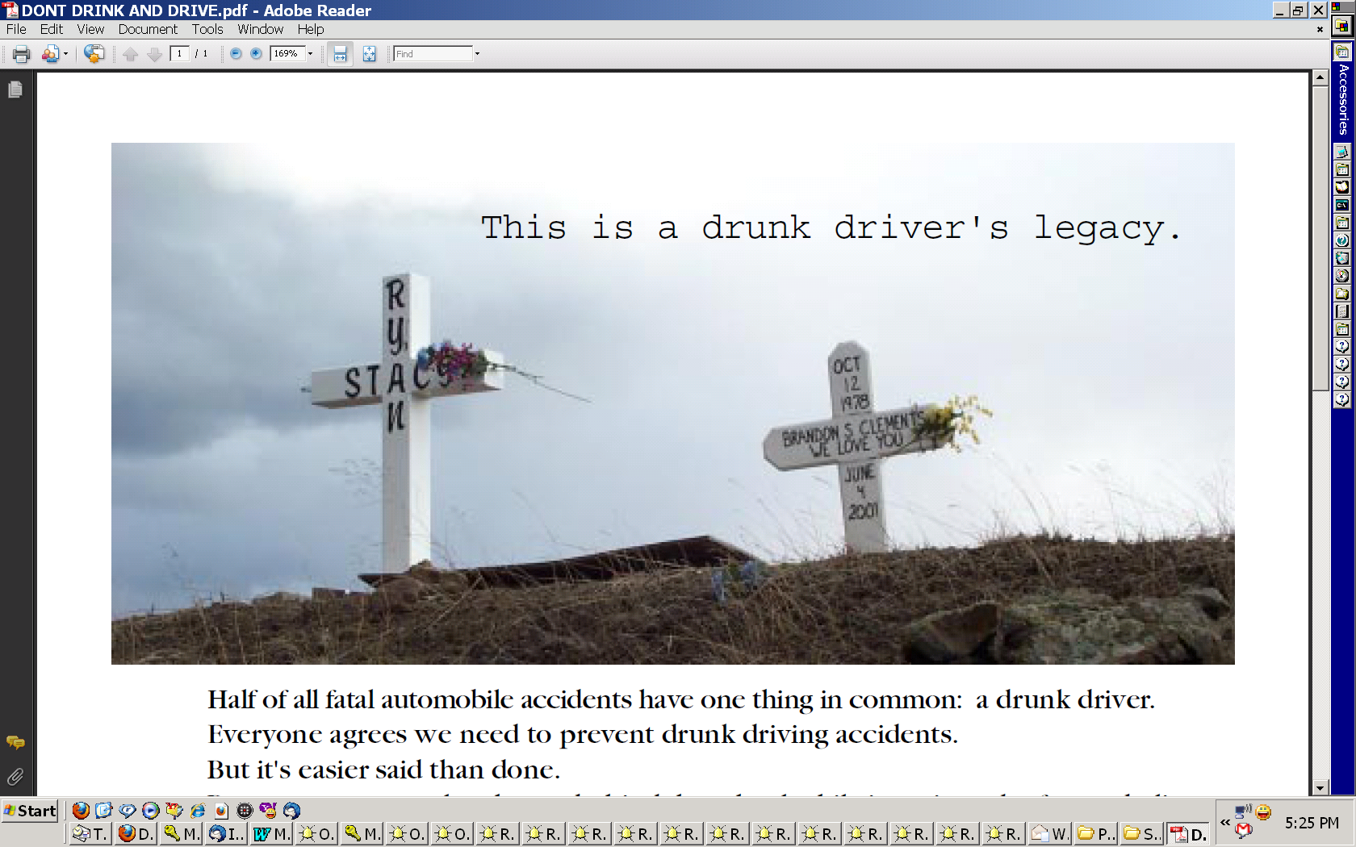
Half of all fatal automobile accidents have one thing in common: a drunk driver.
Everyone agrees we need to prevent drunk driving accidents.
But it's easier said than done.
Because most people who get behind the wheel while intoxicated refuse to believe their ability to drive safely is impaired.
Until it’s too late.
In every drunk driving accident, the innocent suffer with the guilty. In fact, we all share the burden of rising insurance premiums and higher taxes resulting from these accidents.
Some pay a much higher price.
We want to help reduce the number of alcohol-related accidents in our area. That's why we're inviting YOU to partner with us in launching a hard-hitting new "Don't Drink & Drive" campaign on (CALL LETTERS).
By lending your name to this community-wide effort, you'll be sending a powerful message to your customers and business associates, your friends and neighbors: We care about you. Please Don't Drink and Drive!
Here's where you place your specific proposal or package information. You may wish to consider a package that combines a certain number of DD&D features, tagged with sponsor ID along with a regular package of ads which can be used monthly at the advertiser’s discretion. For example:

Aggressive: 40 features per month plus 100 ads per month

Moderate: 30 features per month plus 75 ads per month

Conservative: 20 features per month plus 50 ads per month

Yes! Count us in! We'd like the __________ plan at $____/month for ___ months starting ____.

Advertiser: ____________________ Authorized by: ________________ Date: _______

